
DIGITAL ASSIGNMENT 5

Name: Soumyadeep Ganguly
Reg No: 24MDT0082
Course: Big Data Analytics Lab
Course Code: PMDS507P

Implement and execute a matrix multiplication program using the Hadoop MapReduce framework. The Mapper and Reducer logic will be implemented in Python.

1. Input Data Files
The input consists of two text files, A.txt and B.txt, representing the two matrices. Each line in these files has the format: matrix_name row_index column_index value.
- Matrix A (A.txt):
- Matrix B (B.txt):
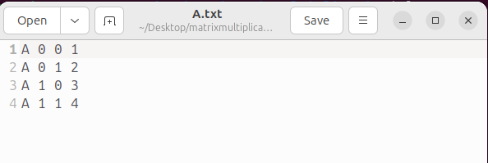
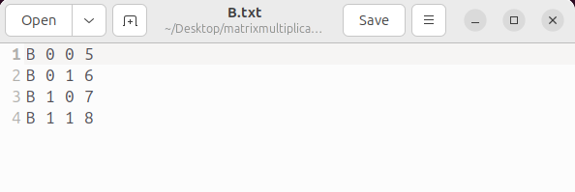

2. Mapper Script (mapper.py)
The Python script mapper.py reads data from standard input. For each element from matrix A, it generates intermediate key-value pairs for each column of the output matrix. For each element from matrix B, it generates pairs for each row of the output matrix. The intermediate key is (i, k), representing the position in the final matrix.
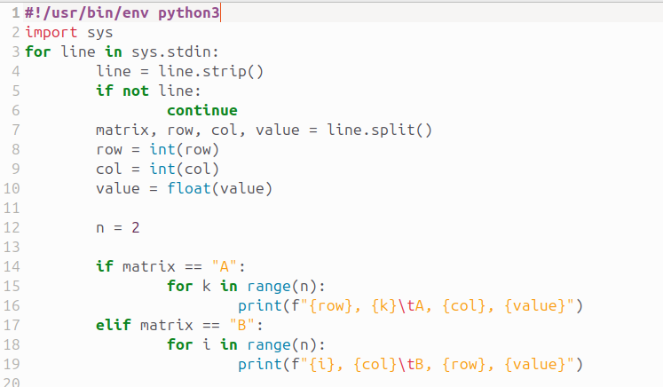
- Code for mapper.py:

3. Reducer Script (reducer.py)
The script reducer.py receives the grouped key-value pairs. For each key (i, k), it collects the corresponding values from matrix A and matrix B into separate dictionaries. It then calculates the dot product to find the value of the cell and prints the final result.
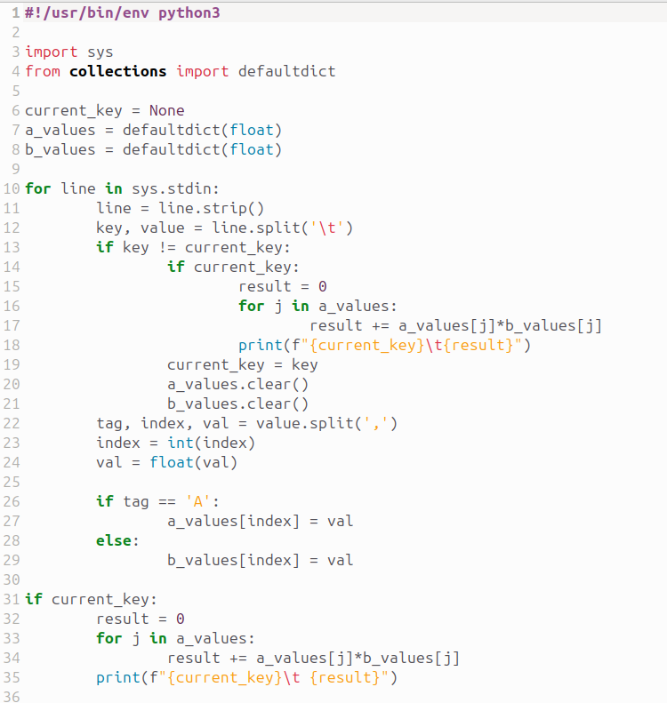
- Code for reducer.py:

4. Preparing HDFS and Scripts
Before running the job, the following preparatory steps were taken:
- The Mapper and Reducer Python scripts were made executable using the chmod +x command.
- An input directory /matrix_input was created in HDFS.
- The input files A.txt and B.txt were copied from the local filesystem to the /matrix_input directory on HDFS.
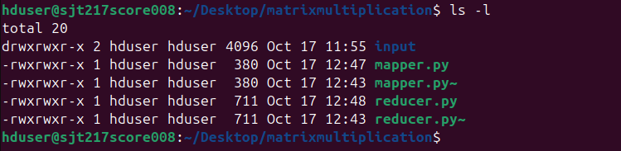
The directory listing below shows the scripts with execute permissions.

5. Executing the Hadoop Job
The Hadoop Streaming utility was used to run the MapReduce job. The command specifies the input and output directories in HDFS, the mapper and reducer scripts, and uses the -file option to make the scripts available to the cluster nodes.
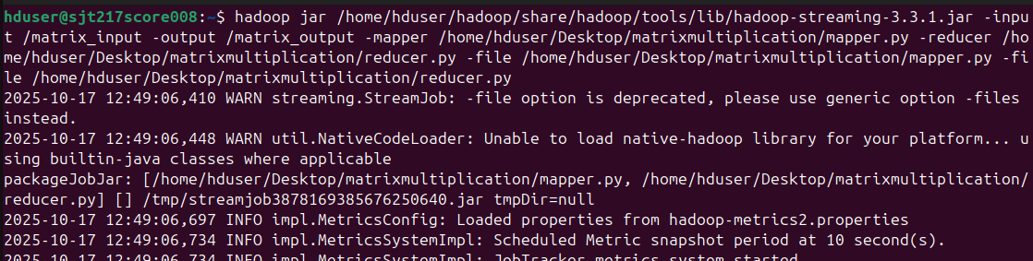

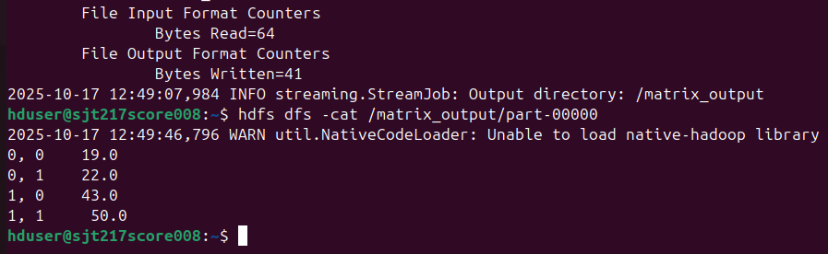
6. Final Output

